**Project Design Phase**

**Solution Architecture**

|  |  |
| --- | --- |
| Date | 28 June 2025 |
| Team ID | LTVIP2025TMID49827 |
| Project Name | Heritage Treasures: An In-Depth Analysis of UNESCO World Heritage Sites in Tableau |
| Maximum Marks | 4 Marks |

**Solution Architecture:**

The solution architecture of *"Heritage Treasures: An In-Depth Analysis of UNESCO World Heritage Sites in Tableau"* involves a streamlined data analytics workflow. The raw UNESCO heritage dataset is first collected and cleaned using Excel or Python for accuracy and consistency. This refined data is then imported into Tableau, where interactive dashboards are built. These dashboards visualize key insights such as regional site distribution, heritage classifications (cultural/natural), endangered sites, and time-based trends, enabling users to explore and interpret global heritage patterns efficiently. Its goals are to:

* To visualize the global distribution of UNESCO World Heritage Sites by region, type, and country.
* To identify and highlight endangered heritage sites and analyze the threats they face.
* To explore trends over time, including the yearly addition of heritage sites.
* To raise awareness about the cultural and natural significance of heritage locations.
* To create an interactive dashboard that supports user-driven exploration and storytelling.

**Example - Solution Architecture Diagram:**

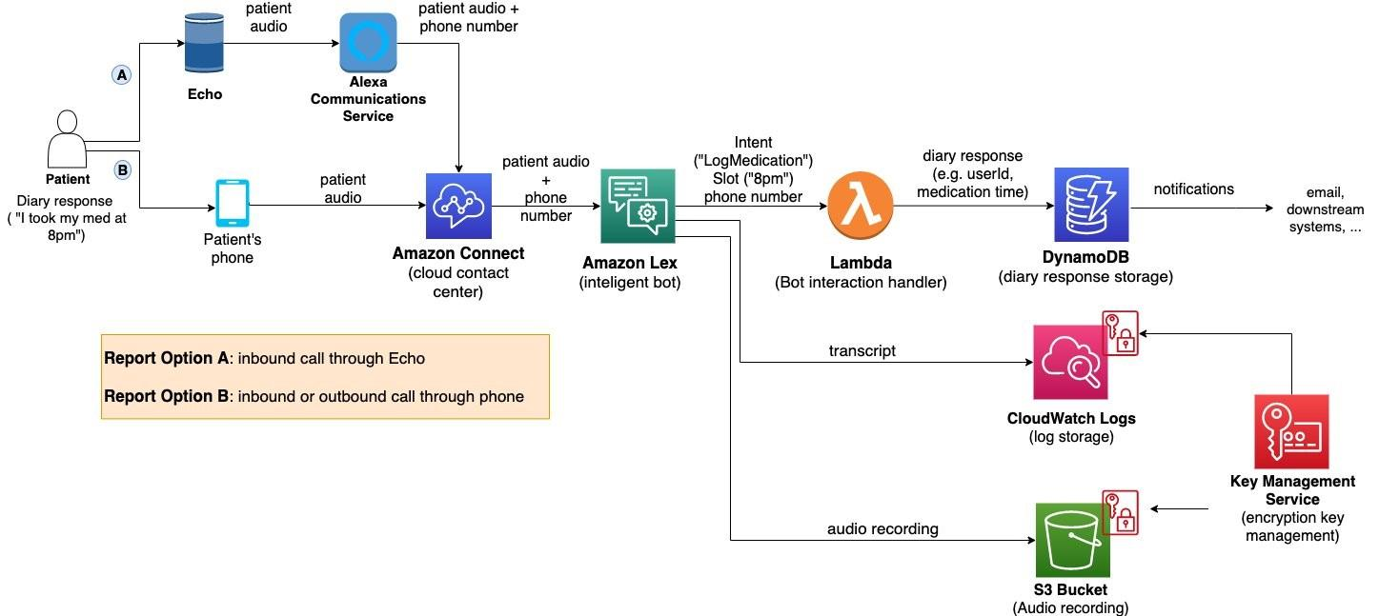

*Figure 1: Architecture and data flow of the voice patient diary sample application*

**Reference:** [**https://aws.amazon.com/blogs/industries/voice-applications-in-clinical-research-powered-by-ai-on-aws-part-1-architecture-and-design-considerations/**](https://aws.amazon.com/blogs/industries/voice-applications-in-clinical-research-powered-by-ai-on-aws-part-1-architecture-and-design-considerations/)